Assessment Cover Page

Module Title: | Data Visualisation and Communication
Assessment Title: | CA1
Lecturer Name: | Taufique Ahmed
Student Full Name and Student Number: | Heloísa Eugênio Silva - 2023264
Assessment Due Date: | 07/11/2026
Date of Submission: | 07/11/2026
Declaration | By submitting this assessment, I confirm that I have read the CCT policy on Academic Misconduct and understand the implications of submitting work that is not my own or does not appropriately reference material taken from a third party or other source. I declare it to be my own work and that all material from third parties has been appropriately referenced. I further confirm that this work has not previously been submitted for assessment by myself or someone else in CCT College Dublin or any other higher education institution.

Introduction
The main purpose of this project is to visualise and understand a large dataset. For this assignment, I was required to explore employment in three different areas, such as Artificial Intelligence, Data Science and Software Development, using the U.S. Bureau of Labour Statistics (2019) Dataset
Using Python, Pandas, Matplotlib, and Seaborn, I created 5 charts to compare employment numbers, annual median wages, and employment across different locations.
In addition, a final challenge involved using two more datasets from 2021 and 2022 to investigate how employment in those three technology occupations changed over time.

AI use
ChatGPT was an important support tool throughout my project; it helped me understand Python functions and improve my work.

AI was used for

Chart ideas
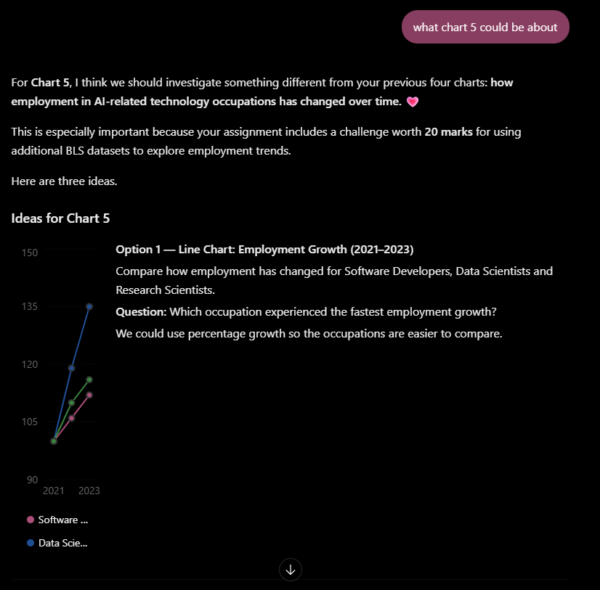
ChatGPT helped me by giving me ideas for charts. At first, I didn't know much about what to discuss or even which chart would be the best option.

ChatGPT helped me to choose my charts and understand better which topics I could explore using my dataset.

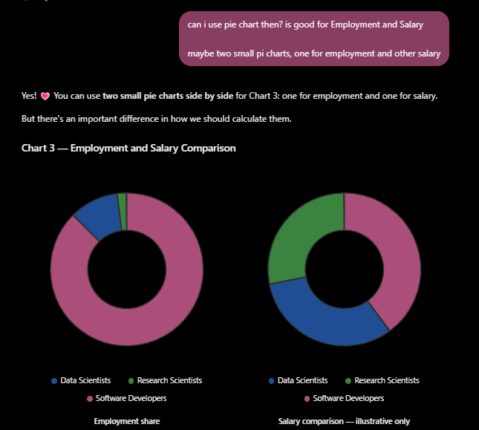

Understand data visualizations
I used ChatGPT to help me understand different visualisations and how to interpret the results. Sometimes I found it difficult to understand what the charts were showing, so I asked ChatGPT multiple times for better explanations. This helped me to identify the relationships in the data and results more clearly.

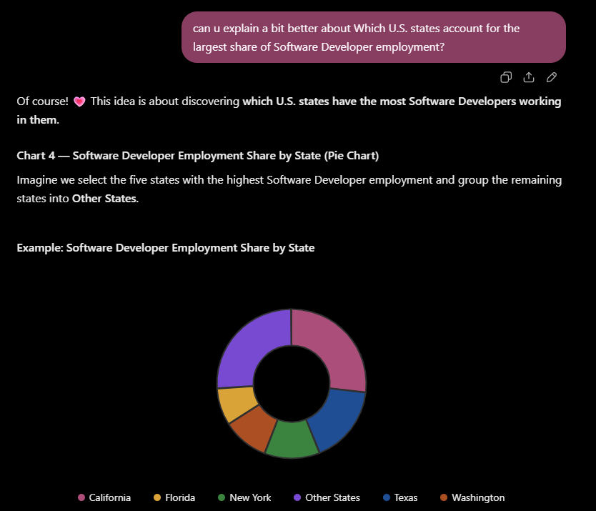

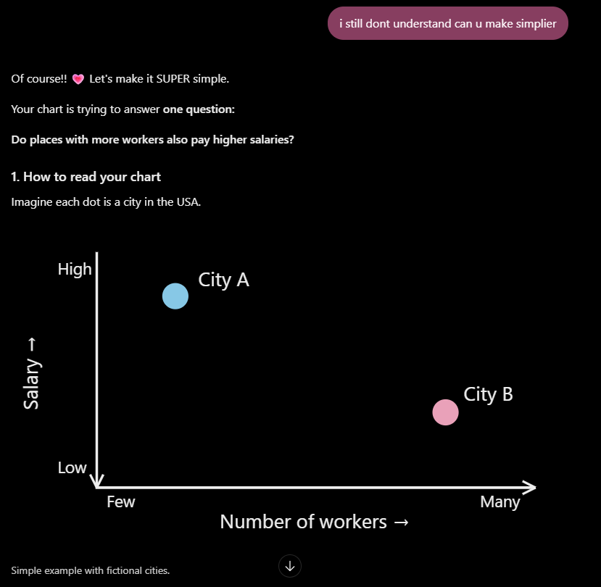

Grammar
As a non-native English speaker, I sometimes struggled with grammar and finding the perfect words to explain my ideas. ChatGPT helped by fixing grammar mistakes, improving sentences and making my ideas clearer.

80% of the time, I was writing my paragraphs and then asking ChatGPT to improve them while keeping my own ideas and writing style.

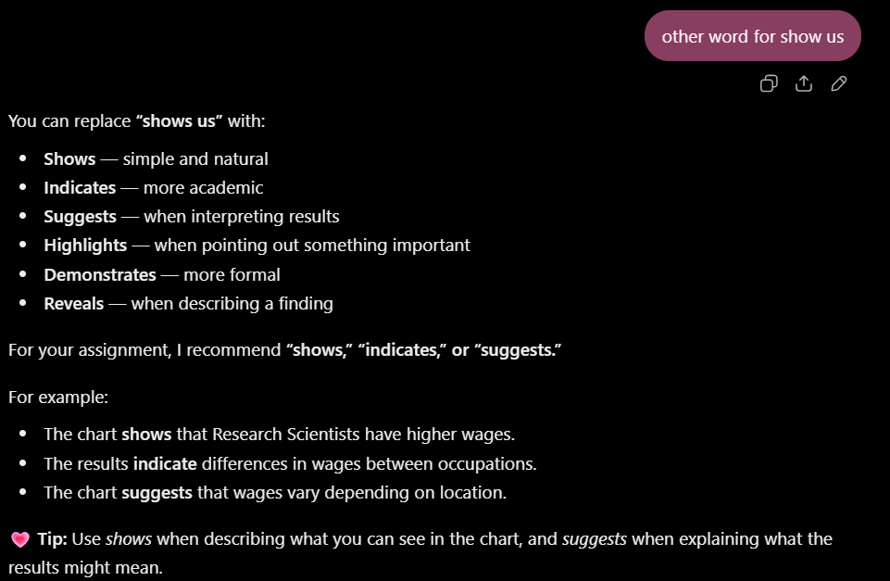

Python support
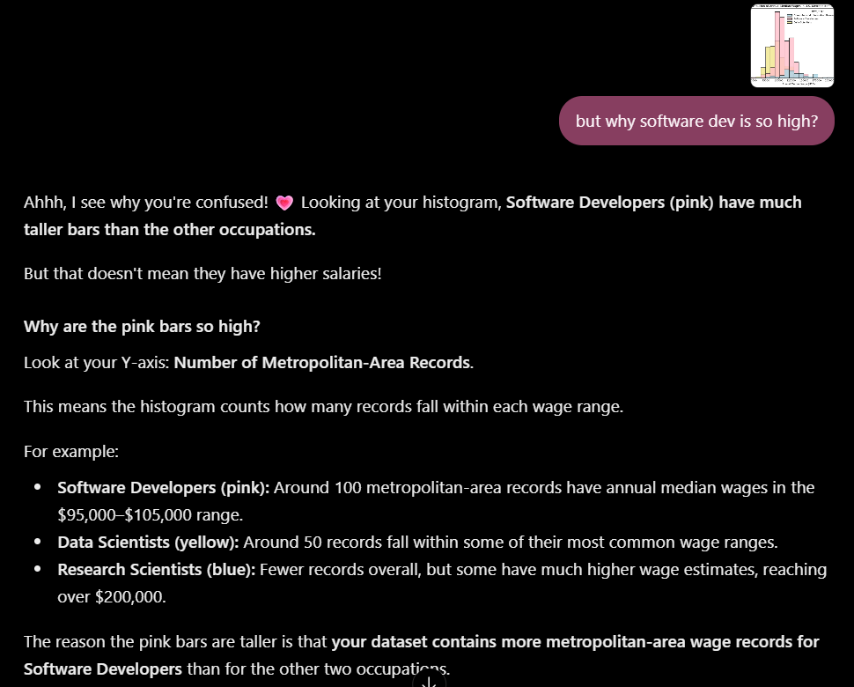
While using my own lecture notes to understand and write the code, ChatGPT helped me identify and fix errors, create functions I wasn't sure how to implement and suggest improvements to the code.
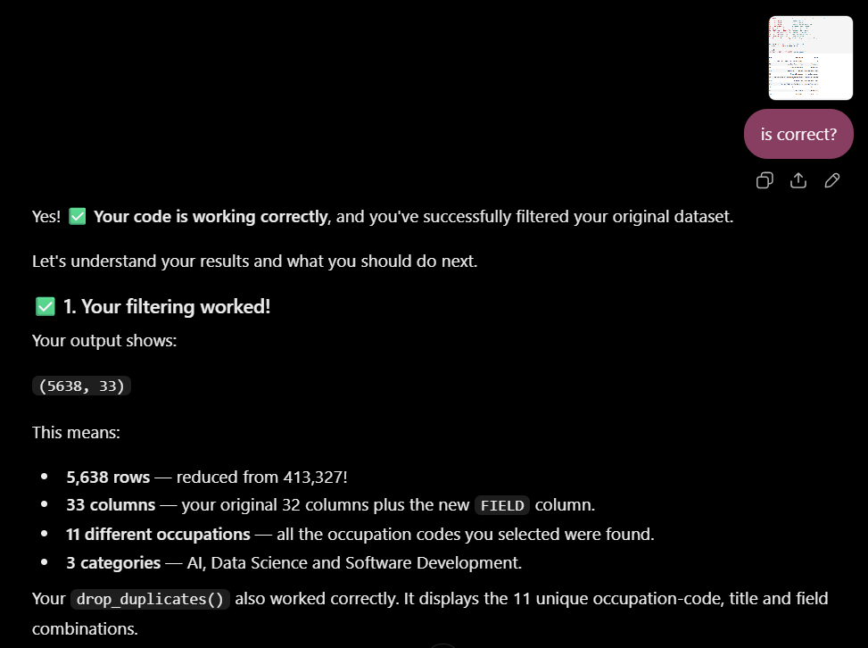

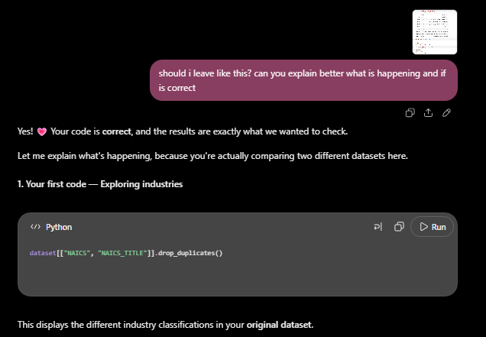
ChatGPT also made small improvements to my chart, such as changing the colours for each occupation to make the charts clearer and easier to understand.

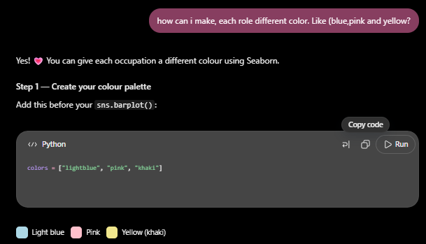

Dataset Link
https://www.bls.gov/oes/tables.htm

U.S. Bureau of Labour Statistics (2019). Occupational employment and wage statistics. [online] Bls.gov. Available at: https://www.bls.gov/oes/tables.htm [Accessed 7 Nov. 2026].

GitHub
https://github.com/HeloEugenio0916/Data-Visualisation-and-Communication-CA1/commits/main/

